Ameba如何更換DAP Firmware

如何更換DAP Firmware?
要更換DAP firmware，請參考以下操作
1. 按住CON2旁邊的按鈕不放
2. 按一下CON1旁邊的按鈕
3. 放開在第一步按住的按鈕
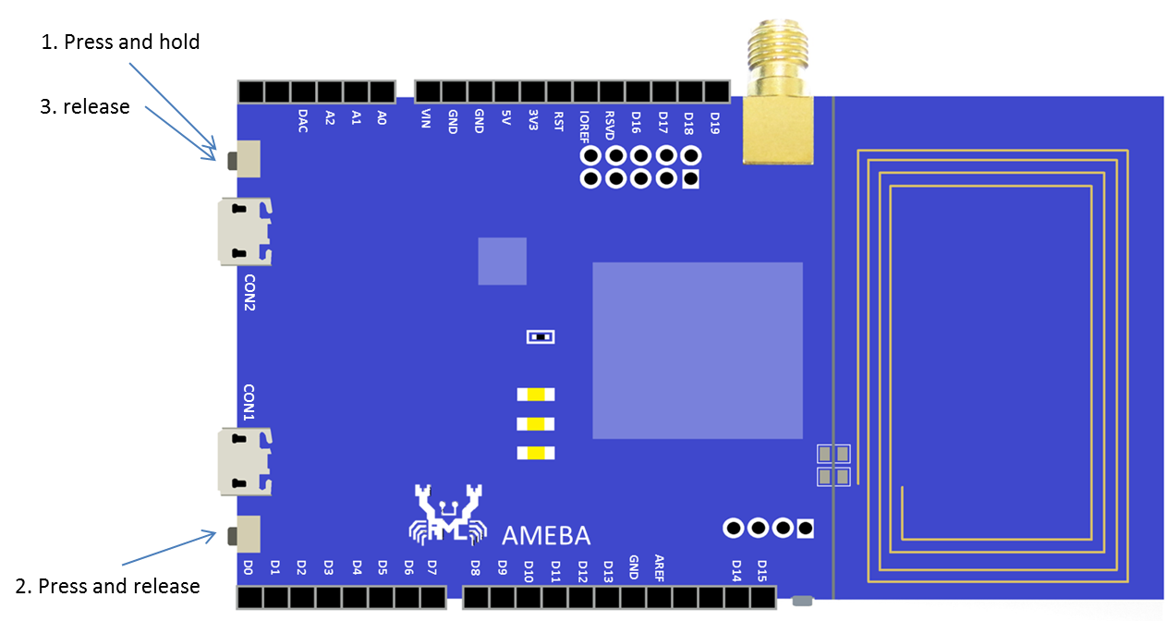
此時會出現一個磁碟槽，上面的標籤為 “CRP DISABLED”
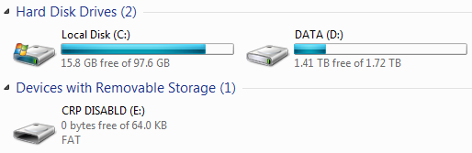
打開這個磁碟，裡面有個檔案 “firmware.bin”，它是目前這片Ameba使用的DAP firmware
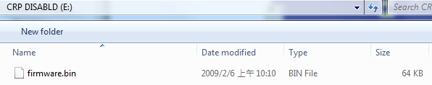
要更換firmware，可以先將這個 firmware.bin 備份起來，然後刪掉，再將新的DAP firmware用檔案複製的方式放進去
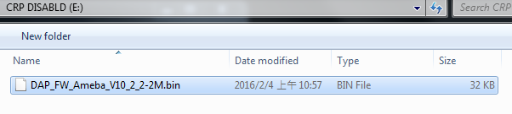
最後將USB重新插拔，新的firmware就生效了。
底下是目前的DAP firmware列表:
Version | Description | Link
DAP_FW_Ameba_V10_2_3-2M | 1. Improve upload speed.  2. Won’t restart DAP after upload finished. | Download
DAP_FW_Ameba_V10_2_3-2M_LED_Disable | 1. Improve upload speed  2. Won’t restart DAP after upload finished.  3. Turn off DAP LED. | Download
DAP_FW_Ameba_V10_2_2-2M | 1. Won’t restart DAP after upload finished. | Download
DAP_FW_Ameba_V10_2_2-2M_LED_Disable | 1. Won’t restart DAP after upload finished.  2. Turn off DAP LED | Download
DAP_FW_Ameba_V9_2-2M_Signature.bin | Check file extension and image signature | Download
11u35_ameba_if_mbed_0_7_seperate | Original version | Download

